

Business Requirements & Specifications

NCLH Fortinet FSSO Redesign

Version | Date Published | Description | Author
1.0  1.1 | 12/17/2024  01/07/2025 | Initial Draft  Updates | Dina Leznova, Eduardo Cendan

Table of Contents
1. Overview 3
1.1 Executive Summary 3
1.2 Scope 3
1.3 Project Resources 4
1.4 Stakeholders 4
2. Requirements 5
2.1 Business Requirements 5
3. Process Maps & Diagrams 6
3.1 As-Is (Current) 6
3.2 To-Be (Future) 6
4. Appendix 7
4.1 Document Terms, Acronyms & Definitions 7
4.2 References 7
5. Sign Off 8

1. Overview

Executive Summary
Currently NCL deployment has both the FSSO Collector Agent (CA) and the Domain Controller Agents on the ship’s Domain Controllers. Since the Network Team does not have direct management access to these Domain Controllers, this setup has presented several challenges such as dependency on Server team, limited access hindering troubleshooting/upgrades, miscommunications, and complexities with backup/recovery.
To address these issues, the recommended architecture involves deploying the FSSO Collector Agent on a dedicated VM. This solution also provides the Network Team with greater control, faster troubleshooting, and enhanced redundancy for the FSSO service.

1.2 Scope
- In-Scope: All Brands, Harvest Caye, Great Stirrup Cay
- Deploying the FSSO Collector Agent on a dedicated virtual machine, separate from the domain controllers.
- Domain Controller Agent:
The Domain Controller (DC) Agent must be installed on each domain controller when operating in DC Agent mode. The DC Agents monitor user logon events and pass this information to the Collector Agent, which stores and forwards the data to the FortiGate unit.

1.3 Project Resources

Role | Name |  | Job Title | Email
PM |  | Eduardo Cendan | Project Manager | ecendan@ncl.com
BA |  | Dina Leznova | Business Analyst | dleznova@ncl.com
PM |  | Simon Falcon | Portfolio Director | sfalconl@nclcorp.com
IT Network |  | Manuel Sosa | Lead Shipboard Network Ops | msosa@nclcorp.com

1.4 Stakeholders

Business
Area | Name | Job Title | Email
Executive Sponsor | Georgios Mortakis | VP, CISO | gmortakis@nclcorp.com
Initiative Owner | Jamlet Tapanes | Dir Network Svcs Shipboard | Dir Network Svcs Shipboard

2. Requirements

2.1 Business Requirements

# | Function | Business Process | Current vs. Future State | Requirement / User Story | Brand Impact | Priority
1 | General | Backend Rules/Data | Future | Deploy the FSSO Collector Agent (CA) on a dedicated virtual machine, separate from the domain controllers | Tri-Brand | Must Have
2 | General | Backend Rules/Data | Future | Deploy the server under the Network Team’s management | Tri-Brand | Must Have
3 | General | Backend Rules/Data | Future | Configure multiple CAs for redundancy | Tri-Brand | Must Have

Collector Agent Details

The Collector Agent (CA) monitors user logons within the Windows AD network and sends necessary authentication information to the FortiGate. Key functionalities include:

- DNS Lookups, Group Verification, and Workstation Checks: The CA verifies user credentials, group memberships, and workstation status before relaying logon records to FortiGate.
- Communication with FortiGate Devices: The CA communicate with FortiGate over TCP port 8000 for logon information updates and listen on UDP port 8002 to receive updates from the DC Agents.
- Redundant CA Configuration: Multiple CA instances can be configured on FortiGate for high availability. If one becomes unreachable, FortiGate will attempt connection to the next configured CA in sequence.

2.2 Technical Requirements
CA VM Requirements:

For environments opting for a dedicated CA VM, the following specifications are recommended based on deployment size:

- Light Load: 2 vCPUs, 8 GB RAM
- Medium Load: 4 vCPUs, 16 GB RAM
- Heavy Load: 8 vCPUs, 32 GB RAM

Any server capable of running Windows Server OS should be sufficient for the FSSO Collector Agent, but the above guidelines ensure optimal performance.

Process Maps & Diagrams

3.1 As-Is (Current)
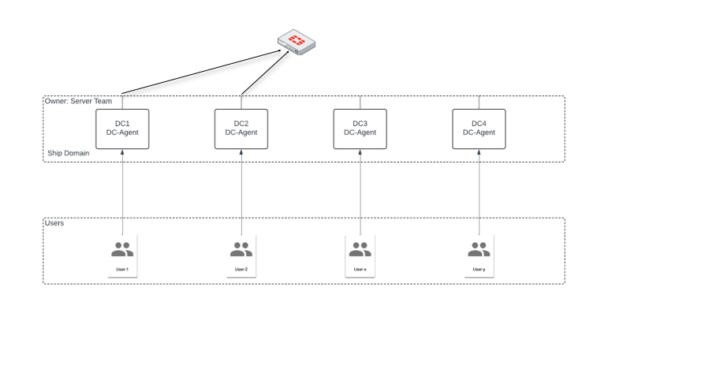

3.2 To-Be (Future)
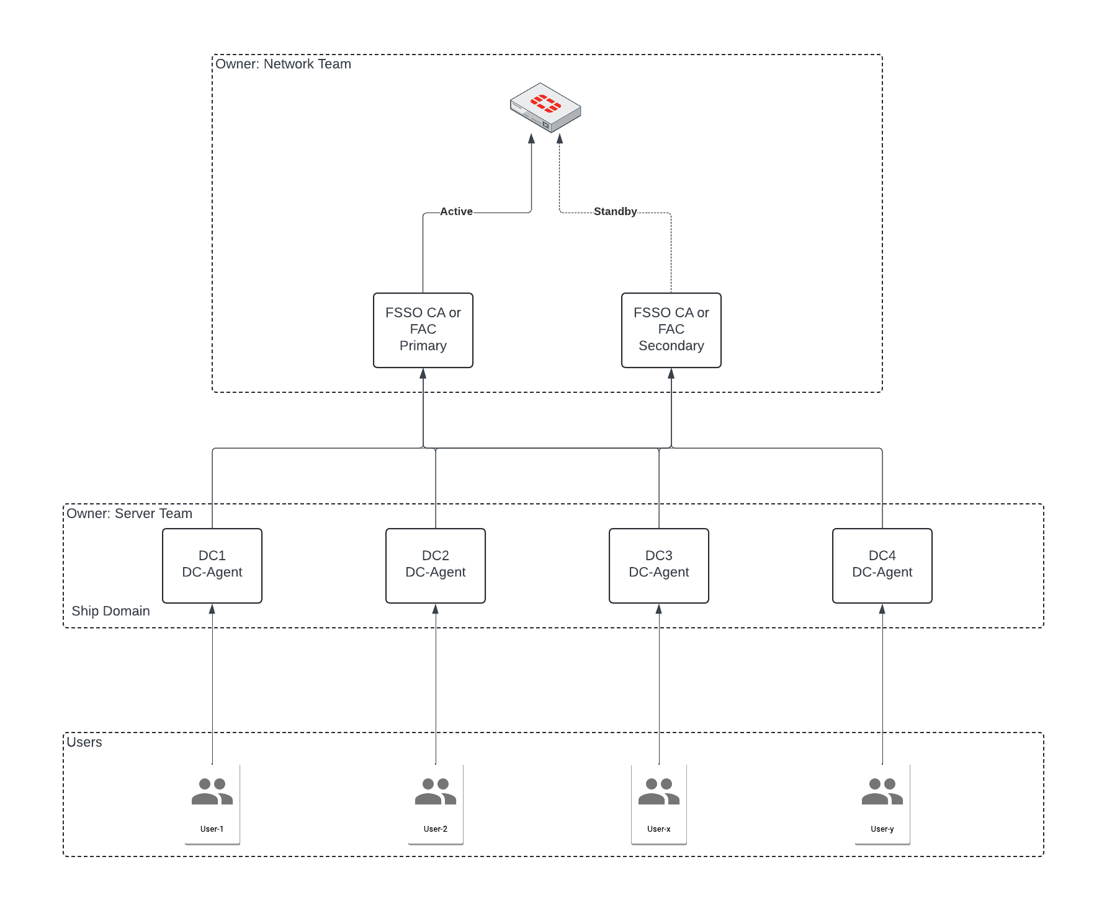

4. Appendix

4.1 Document Terms, Acronyms & Definitions
Term/Acronym | Definition
CA | Collector Agent
DC | The Domain Controller Agent

4.2 References

4.3 Vendor who will support the system.
Fortinet

5. Sign Off

By providing your signature/email approval below, you as a Stakeholder attest that the requirements have been reviewed, and that it captures the general desired business outcome.

Approver Name | Job Title | Signature | Date

